Name: Shay Walker

Box #: 613

Professor Sabal

Cairn University School of Business

CIS122 Essentials of Networking

Project #2

Project objective:

Testing and maintaining port connectivity on a network that is closely located in relation to one another or any that are further apart. This process insures that the there are no malfunctions within equipment or equipment set up and tests the functionality of the network across computer operating systems interfaces, in this case Linux to Windows and vice versa.

Equipment used:

|  |  |  |  |  |
| --- | --- | --- | --- | --- |
| Equipment Description | Vendor | Vendor Item # | Retail price | Actual price (if known) |
| Linux Computer (Ubuntu Server)  WORKSTATION ONLY | Zones | 004895183 | $841.99 | N/A |
| Windows Computer  (Windows Server 2012)  WORKSTATION ONLY | Zones | 004895183 | $841.99 | N/A |
| Ethernet Switch(s) | Zones | 01440484 | $185.99 | N/A |
| CAT5e cable | Zones | 00146912 | $119.00 | N/A |
| Fiber Optic Cable  (Bulk) | Zones | 03222470 | $390.99 | N/A |
| RJ 45 connectors (qty50) | Zones | 00506365 | $8.58 | N/A |
| Crimper (CAT5/6 UTP) | Home Depot | 206304274 | $13.13 | N/A |
| Scissors | Walmart | 565618788 | $1.16 | N/A |

Detailed list of software and operating platforms used, including version numbers and licensing requirements:

Ubuntu Server (Linux) (Command Line)

Windows Server 2012:

Network diagram:

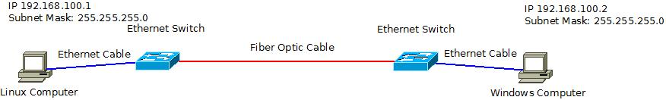

Configurations:

The ifconfig command was used on the computer running Ubuntu Server (Linux) to set the static IP address to 192.168.100.1 and the netmask to 255.255.255.0. While on the Windows computer the Control Panel was used to get to the Network and Sharing Center, then to the Internet Connection Properties to view and change the IPv4 address and the subnet mask to the static IP address of 192.168.100.2 and the subnet mask of 255.255.255.0. Thus, making the two computers apart of the same network so that they could potentially contact one another with the proper equipment set-up and proper function. Which in this case involved two Ethernet switches, Ethernet cabling, and fiber optic cabling. The computers were connected to the network through ethernet cables which were tested for functionality prior and were ensured to function properly. These Ethernet cables were connected to a separate Ethernet switch within the cabling range. Fiber optic cabling was then tested and used to connect the two switches due to the distance and (or) location of these two computers.

Once the proper installation of the equipment is intact, the ping command was used to test the connectivity over the network using the static IP addresses that were defined in ifconfig and ipconfig. The Linux computer will continually search for the designated connection when the ping command is used, whereas the Windows computer will stop search after four failed attempts. Ping indicated how many milliseconds the connection took upon being successful. All connections were made successfully.